WATS Gunaisnghe and Roshell Askey National Amateur Chess C’hips 2015

Sri Lanka National Amateur Open & Women Chess Championships 2015 was held from 05th to 09th August 2015, at the Buddhist Ladies College, Colombo 07. The Chess Federation of Sri Lanka organized this event for the 2nd Consecutive year with a cash award of Rupees 220,000/=. Both the tournaments were 09 rounds, Swiss FIDE Open International Rating Event with 143 players and 53 players respectively in Men & Women events.

Two players, WATS Gunasinghe and Thisura Munasinghe of Kotalawala Defense Academy tied for the first place in open event at 7.5/9 points each at the conclusion of the event and WATS Gunasinghe achieved the championship on a superior tie break score and received the gold Medal, Winners Trophy and Rs. Thirty Thousand in Cash while Thisura received the Silver medal with Rs. 20,000 in cash.. Lakshitha Randil of Fisher Chess Club became the second runner with 7/9 points and received the Bronze medal and Rs. 15,000/= in cash.

Two young girls Roshell Nathasha Askey from Ave Maria Convent, Negombo and WCM KKM Sachintha Kodikara of Wycheli International School tied for the first place in Women event with 7.5 each out of possible 9 points. However Roshell Nathasha Askey achieved the championship on a better tie breaker and received the Winners Trophy, Gold Medal and Rs. 22,000/= in cash while Sachintha received the Silver Medal with Rs. 15,000 in cash. HHM Janandani Abeyshinghe of Girls High School, Kandy became the second runner with 6.5/9 points to receive the Bronze medal with Rs. 8,000 in cash.

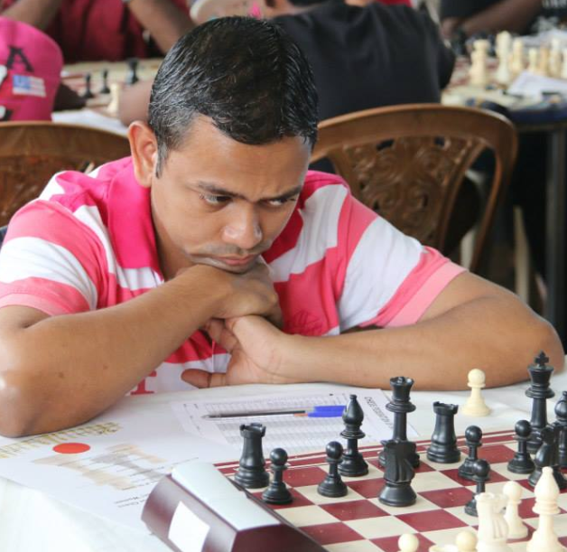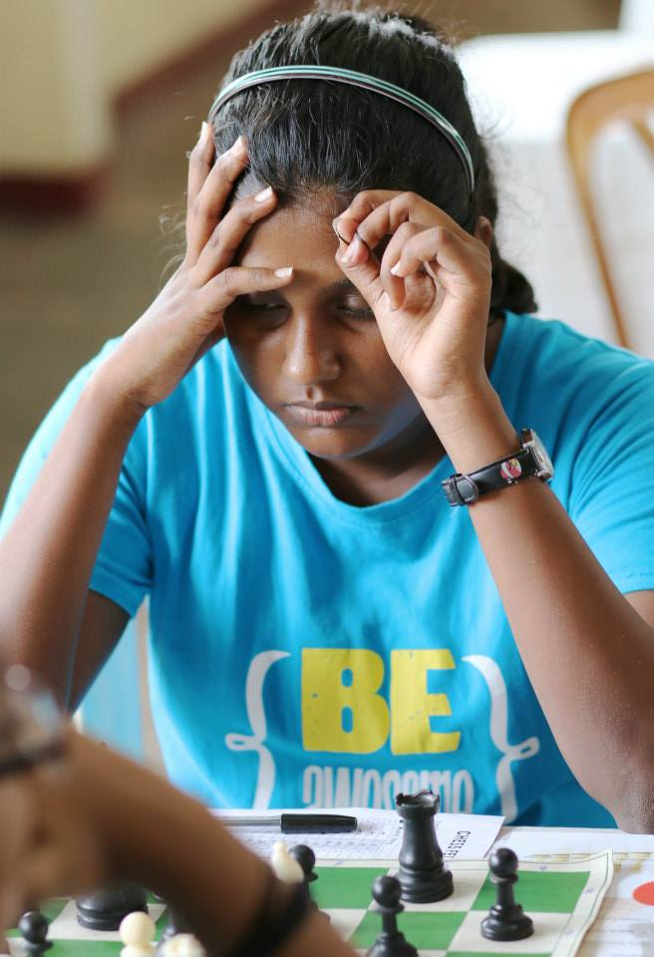
WATS Gunasinghe, National Aamteur Champion Roshell Askey, National Amateur
Women’s Champion

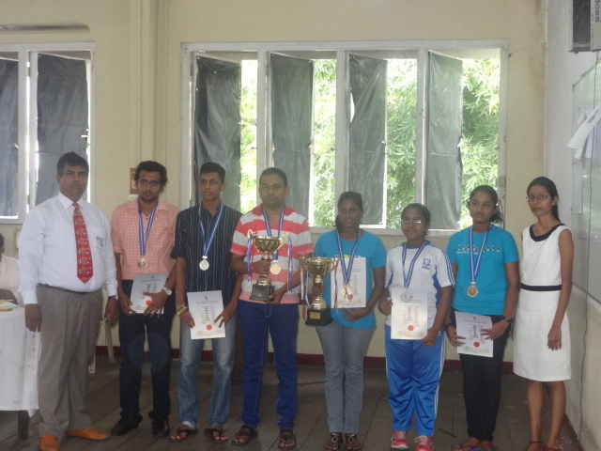
All medal winners
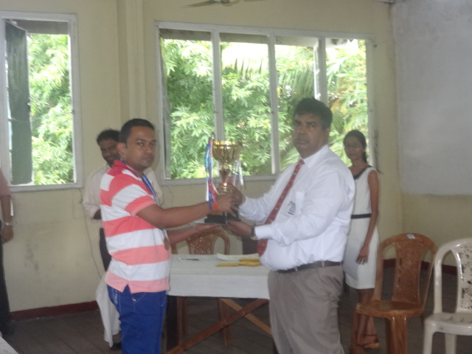
WATS Gunasinghe receiving his Award from Mr. Luxman Wijesuriya
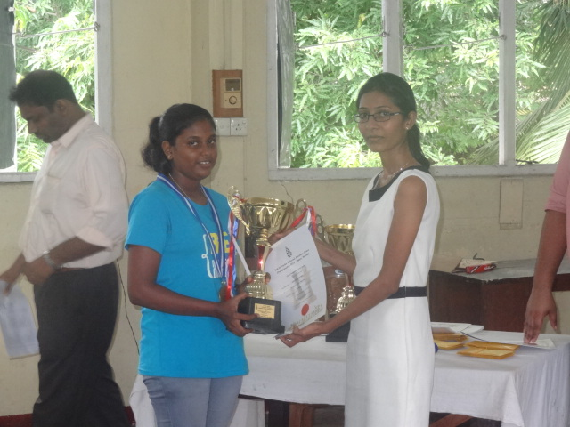
Roshell receiving her award from Miss Buddhi Panagoda, Hony. Secretary – CFSL

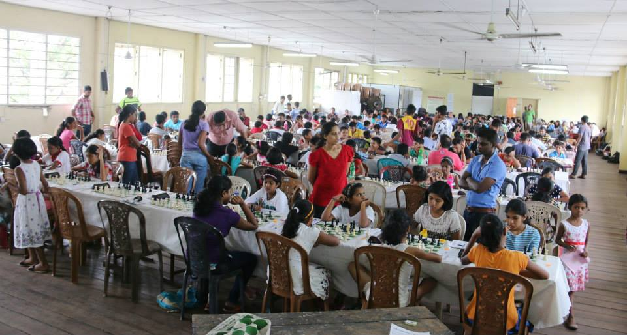
Playing Hall

